**Table of contents**

**Sr. No Topic Page No.**

1. Introduction 1

* 1. Abstract of Project 2
     1. Objective 3
  2. Problem Specification/Need of Project 4

2. Feasibility Study 6

3. Software Requirement Specifications 7

* 1. Introduction 7
  2. Specific Requirements 8
  3. Selection of Technology 9

4. Design 14

* 1. ER Diagram 16
  2. Data Flow Diagram 17
  3. Modules 18
  4. Database 20
  5. Input-Output form (Screen Layout) 23

5. Testing & Results 26

6. Limitations 28

7. Conclusion & Future Scope 29

Bibliography

Appendix A: Coding

A

# A PROJECT REPORT

# ON

## “Online library Management System”

# GITAM

Submitted to:

M. D. University, Rohtak( Haryana)

in partial fulfillment of the requirement for the award of degree of

#### **MASTER OF COMPUTER APPLICATIONS**

#### SESSION: 2018-20

#### http://www.bestcollegehunt.com/images/ganga_logo.png

**Under the Supervision of: Submitted by:**

Dr. Neetu Sharma Rohit Prasad

HOD, CSE

**GANGA INSTITUTE OF TECHNOLOGY & MANAGEMENT, KABLANA, JHAJJAR**

M. D. University, Rohtak -124001( Haryana)

**GANGA INSTITUTE OF TECHNOLOGY & MANAGEMENT**

**DEPARTMENT OF COMPUTER SCIENCE & APPLICATIONS**



Certificate of Completion

This is to certify that the project entitled **“Online Library Management System”** carried out by **Rohit Prasad**, a student of **Master of COMPUTER APPLICATIONS 6th SEMESTER**, **of Ganga Institute of Technology and Management, Kablana, Jhajjar**, at **Ganga Institute of Technology and Management, Kablana, Jhajjar** is a satisfactory account of the bonafide work under my supervision, is recommended towards the end of his 6th semester of **MCA.**

**Project Incharge Rohit Prasad**

**Narender Solanki MCA 6th Sem**

**HOD, MCA**

Certificate From Organization

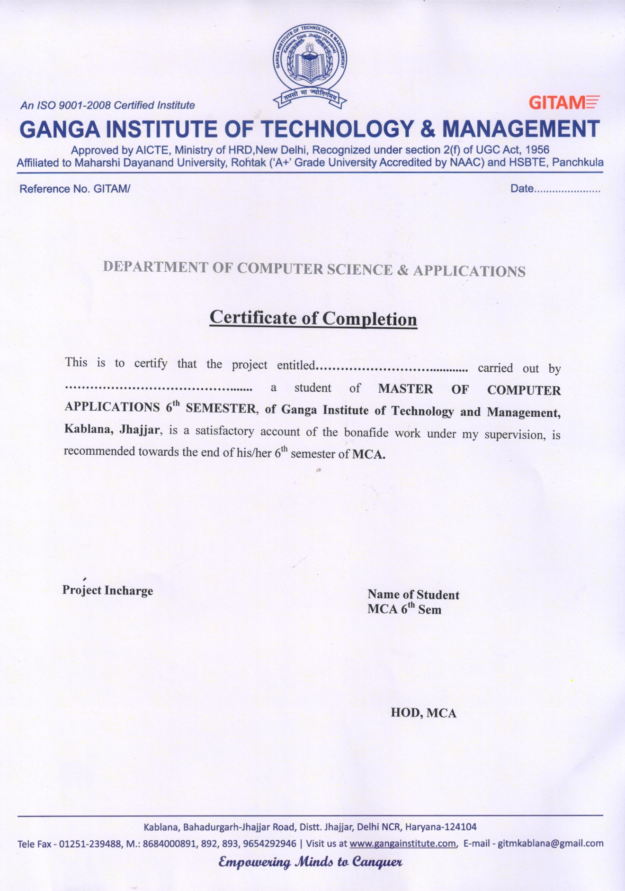

**DECLARATION BY THE CANDIDATE**

I, Rohit Prasad, hereby declare that the project work entitled **“Online Library Management System”** is an authenticated work carried out by me at **Ganga Institute of Technology and Management, Kablana, Jhajjar** for the partial fulfillment of the award of the degree of **MCA** and this work has not been submitted for similar purpose anywhere else.

**Date:**

**Place: ROHIT PRASAD**

**Roll No.**

**MCA 6th SEM**

**ACKNOWLEDGEMENT**

We are very thankful to everyone who supported us for this project and gives there guidance to complete our theses effectively and moreover on time.

We are equally grateful to our teacher Mr. Narender Solanki, who gave us moral support and guided us in different matters regarding the topic.

We feel immensely proud in extending our heartiest thanks to Mrs. Neetu Sharma, HOD, for providing us a platform to improving various fields. They went out of there way and provide us with open hearted help a counsel. They have been source of inspiration for us and there experience and knowledge have helped us in learning and giving this project the shape it has assumed.

**ROHIT PRASAD**

**MCA 6th SEM**